Lab 4 Instrumentation Amplifier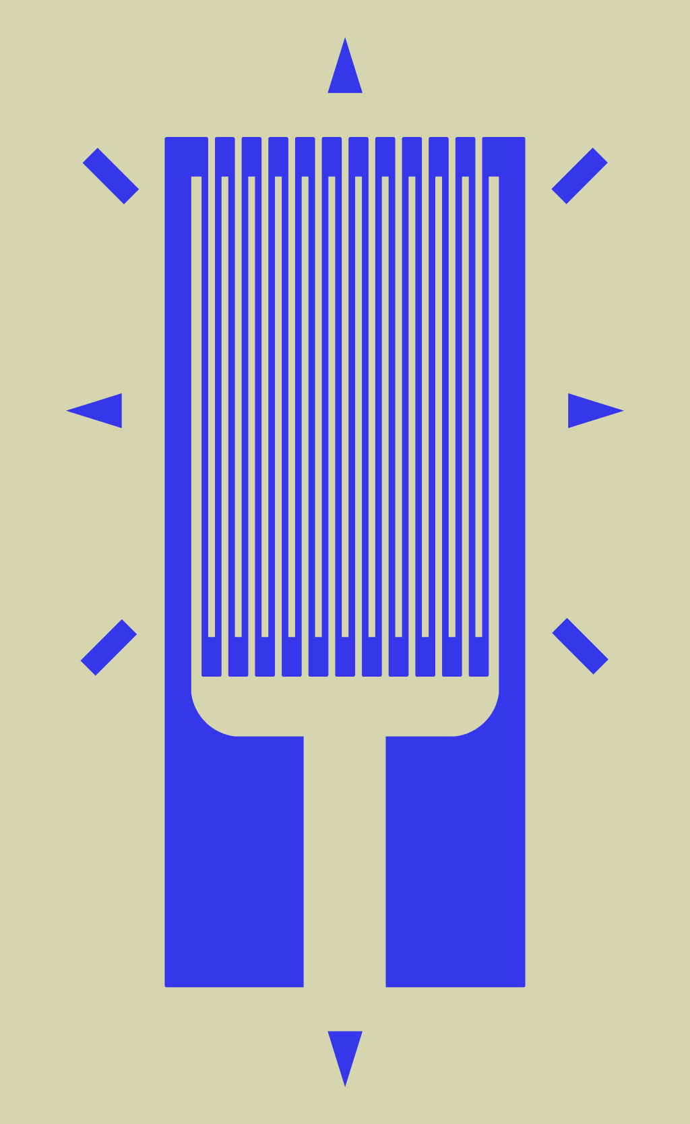

good info on instrumentation amplifiers <https://www.electronics-tutorials.ws/opamp/opamp_5.html>

a)

A strain gauge is an object whose resistance varies with applied force. It can convert force, pressure, tension, weight, etc., into a change in electrical resistance which can then be measured as a voltage output.

A simple but impractical example might be a ductile wire. As the diameter is changed the resistance of the wire would change. The example on the right is designed to measure strain primarily in the vertical direction.

One might also use a potentiometer with a very stiff mechanism :)

The strain gauge is configured in a wheatstone-bridge circuit.

unloaded resistance is 680 ohms

resistance increases at the rate of 0.06 ohms per kilonewton

b)

The maximum strain gauge resistance is 698 ohms.

R_sg_max(F=300kN) = 680 + 0.06*300 = 698 ohms

c)

The differential output of the wheatstone bridge circuit when the maximum load 300kN is applied is approximately 7.5 volts (7.499 volts).

V_od = 15*R_sg_max / (R_sg_max + 680) - 15/2

15*698 / (698 + 680) - 15/2 = 0.09796806966 ~ 0.1 volts

d)

Connecting the negative terminal of the differential output to the ground of the display output will cause a short circuit.

The displays have an analogue input voltage with a dynamic range of 0-12V. If this system has a two port input then we should not attach the output of the wheatstone-bridge circuit since the negative terminal is not the ground. Would this be a floating ground? Or attempting to have two wires at different voltages be a single ground wire? If I'm right this doesn't seem like a good idea.

e)

It appears that the signal should be amplified by A_vo = 12/0.09796806966 = 122.488888897 ~122

f) <derive equation v_0 = (1+r2/r1)(v1-v2)>

In lab book

g)

v_0 = (1+r2/r1)(v1-v2)

1+r2/r1 = 12/7.5

r2/r1 = 4.5/7.5 = 9/15 = 3/5 = 0.6

r2 = 0.6 * r1

choose r1 = 10k, r2 = 6.2k, r = 10k

V_od+ connects to V_1

V_od- connects to V2

h)

simulate instrumentation amplifier in LT-spice

i)

If the 680 Ohm resistors can vary by up to +/-1% from their specified values what is the magnitude of this DC offset in "the worst case scenario"? What are the undesirable consequences of the DC offset?

R1,R2,R3=680+/- 6.8 ohms

V_od = 15*( R_sg / (R_sg + R1) - R2/(R2+R3) )

If the 680 ohm resistors can vary by 1% the maximum DC offset for the strain gauge output is approximately +/-0.1 volts.

Changes to the minimum voltage

V_od = 15*( 680/(680+673) - 673/(673+687) ) = 0.1160085431 V ~ 0.1V

V_od = 15*( 680/(680+687) - 687/(687+673) ) = -0.1160085431 V ~ -0.1V

Changes to maximum voltage

V_od = 15*( 698/(698+673) - 673/(673+687) ) = 0.21396737031

V_od = 15*( 698/(698+687) - 687/(687+673) ) = -0.01763909534

Varying the resistor values in the wheatstone bridge when the strain gauge is measuring 0 newtons of force gives a DC offset at V_od of approximately +/- 0.1 volts.

With a gain of 122 this corresponds to a voltage of +/-12.2 volts which is about 300kN of force.

xThis could also cause the final voltage to exceed the 12 volt maximum for the display unit depending on the downstream amplification.

j)